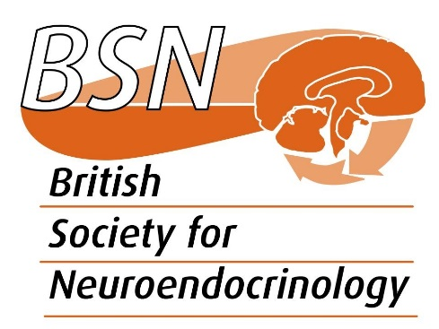

Trustee nomination form

To be returned to the BSN General Secretary (k.ellacott@exeter.ac.uk) before 1st June 2023

Name of nominee:

Position:

Institution:

Membership category:
☐Ordinary (Full – academic or Full - postdoc)
☐Student (Postgraduate or undergraduate)
☐Research technician
☐Retired

Clinically active? Choose an item.

Main areas of research:

Link to University profile or ORCID:

Proposers (Name, Institution, and email address)

Note: At least one of the two proposers must be an ordinary member of the BSN

First proposer:

Second proposer:

Reasons why you would like to join the Trustee Committee (max 150 words):

British Society for Neuroendocrinology, Charitable Incorporated Organisation number 1163115

